Boddington Village Hall Wedding Hiring Agreement between:
- Boddington Village Hall representative named below in clause 3.2 acting on behalf of its management committee
- The person or organisation named in clause 3.3 (“Hirer”).

AGREED as follows
- In consideration of the hire fee described in clause 3.4, the Village Hall agrees to permit the Hirer to use the premises for activities described in clauses 3.5 & 3.6 for the period(s) described in clause 3.1.
- The details inserted in sub-clauses 3.1 to 3.7 below are terms of this agreement.
- This Hire Agreement includes the annexed Standard Conditions of Hire and the Special Conditions of Hire (if any) set out in the attached Schedule.
  - Date(s) required
Date of Wedding Reception
Available from  mid-day on:  (normally Friday prior) |  | Available until  Mid-day on  (normally Sunday after)

  - Village Hall
Registered Charity | 264503
Authorised Representative | Caroline Sheers
Address | 27 Townsend Lane  Upper Boddington  Northants  NN11 6DR
Telephone Number | 01327 261742

  - Hirer
Name
Address
Email
Telephone Number(s)
  - Hire Fee

Hire Fee (£) *
Deposit Paid (£)
Balance to be paid (£)
* For the latest hiring rates please see the current hire rate chart. The rate applicable to this event should be inserted in the box above. Any additional extras may be agreed after (i.e. Drapes etc) and paid separately
  - Cash Bond
A cash bond of £50 will be required at the time of booking. This will be refunded to you as soon as we have inspected the premises after you have cleared up on the following morning provided no damage has been identified or within 28 days. This does not limit the extent of your liability where the damage exceeds this figure.

  - Cancellation Costs
£50 (the cash bond) up to ten days before and 90% thereafter (unless circumstances allow the hall to waive these).

  - Payment Terms
All hire charges are to be paid prior to collecting the keys and payment is preferred via BACS. If paying by cheque, please present this to the Booking officer at least ten days before collecting the keys.

- Use of Premises
Downstairs Hall | Main Hall, Meeting Room and Bar & outside area adjacent to the Field
Upper Hall | Upper Hall may be available if it is not in use for other activities on the day of the event
Playing Fields | Use of the Playing Field for a marquee may be available for a small charge from the Parish Council

- Licences
  - The Village Hall has a premises licence authorising regulated entertainment and licensable activities.
  - The Village Hall has a PRS music licence authorising the performance and playing of live and recorded music.
  - The Village Hall is licenced for the sale of alcohol on the premises.
Will Alcohol be available at your event? | Yes / No

If you answer yes to the above question, we will provide a bar for you under the management of a Village Hall Trustee and in accordance with the terms of the licence. All drinks, alcoholic and non-alcoholic will be purchased through this bar at the prices indicated on our price list.
Boddington Village Hall will seek to supply any specific drinks as requested on a basis to be agreed with the Booking Officer in advance. Full/partial funding of the bar can also be arranged with agreement of the Booking Officer. Boddington Village Hall will supply the glasses and bar staff and staff to serve the welcome drinks.
- The Hirer agrees to be present at the hall during the hiring and comply fully with this Hire Agreement. (An authorised representative may be used when/if appropriate).

- It is hereby agreed that the Standard Conditions of Hire together with any Special Conditions of Hire shall form part of the terms of this Hiring Agreement unless specifically excluded by agreement in writing between the Village Hall and the Hirer.

- None of the provisions of this Agreement are intended to or will operate to confer any benefit pursuant to the Contracts (Rights of Third Parties) Act 1999 on a person who is not named as a party to this Agreement.

- Signed by the person named at 3.2(b) above, duly authorised, on behalf of the Village Hall’s Management Committee:

Caroline Sheers  Hall Representative | 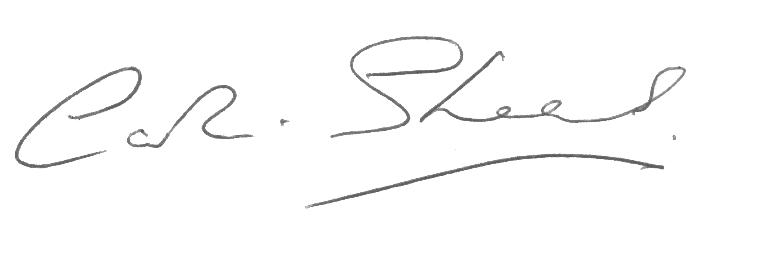

- Signed by the person duly authorised by the organisation named at 3.3 above.

Hirer | Date

- By signing you are agreeing that you have read and understood the full terms and conditions of this hire agreement and the standard terms and conditions that have also been provided to you

